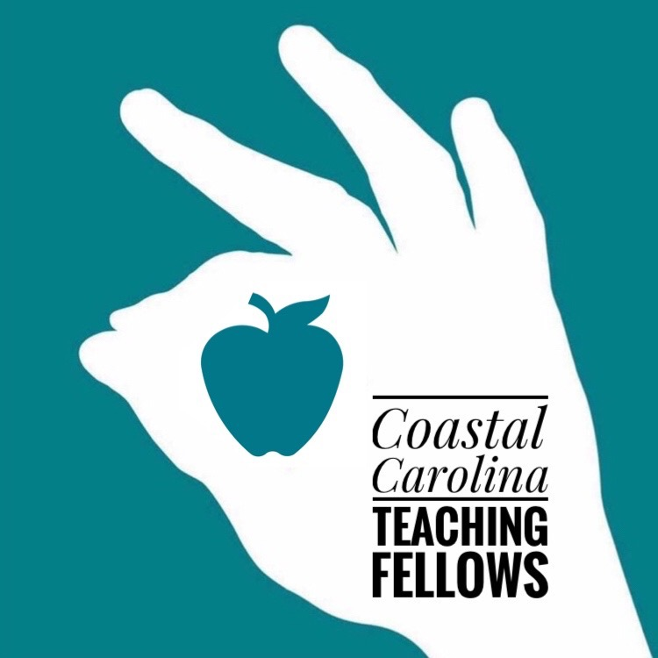 |  | Coastal Carolina University  - College of Education
Teaching Fellows Program:
College of Education
- Undergraduate Certification Programs:
- Early Childhood Education (Grades PK-3)
- Elementary Education (Grades 2-6)
- Middle Level Education (Grades 5-8)
- Special Education (Grades K-12)
- Secondary Education (Grades 9-12): Sciences, English, Mathematics, Social Studies, and Arts and Humanities
- Master’s Degree:
- Master of Arts in Teaching
- -M.Ed. Educational Leadership
- M.Ed. Instructional Technology
- M.Ed. Language, Literacy and Culture.
- Overview:
CCU is highly regarded for its fully accredited and exceptional College of Education that prepares teachers for classroom work in early education, middle, and secondary education.

Emphasis on student centered instruction centered instruction, authentic assessment, and reflective teaching practice are the hallmarks of our education programs.

The College of Education enjoys a rich and close professional relationship with local schools, community agencies and businesses. These partnerships offer teacher candidates diverse and extensive learning and employment opportunities.

CCU Teaching Fellows spend over 2oo hours (on average) in fieldwork placements prior to their student teaching/internship semester. These experiences occur in professional development school sites.

The South Carolina Teacher Loan Program:

Coastal Carolina University
College of Education
- Encourages South Carolina residents to enter the teaching profession. These loans are forgiven by teaching in a SC public school in a critical subject and/or critical geographic area.
To be eligible you must:
- Rank in the top 40% of your high school class
- Be a SC resident
- Be a citizen or permanent resident of the United States
- Have a SAT or ACT score equal to or greater than the SC average for the year of graduation from high school.
The loan must be reapplied for every year:
- Freshman and sophomore may borrow up to $2500 per year. Juniors, seniors, and graduate students may borrow up to $5000 per year. If a borrower decides not to teach or does not teach in a critical area, the loan must be repaid.

To maintain eligibility, you must:
- Re-apply each year
- Undergraduates must have a cumulative GPA of at least a 2.75 on a 4.0 grade scale
The South Carolina Teaching Fellows Program:
- The South Carolina Teaching Fellows Program is designed to recruit up to 200 talented high school seniors annually who have exhibited high academic achievement, a history of service to their schools and community, and a desire to teach in South Carolina and equip them to become effective and successful educators.
- Students who receive a Teaching Fellows award go through a rigorous selection process, which includes an online application, an interview and presentation in front of a team of three educators, and a scored response.
- Applicants who are awarded a Fellowship receive up to $24,000 in yearly scholarships (up to $6000 a year in 4 years) to attend a Teaching Fellows Institution in South Carolina.
- Teaching Fellows must successfully complete 120 credit hours and maintain a minimum GPA of 2.75 during their undergraduate career.
- A Fellow agrees to teach in South Carolina one year for every year he or she receives the Fellowships. Should a Fellow decided not to repay the fund through service in the classroom, he or she is obligated to repay the state through financial means.
Federal Education Assistance for College and Higher Education (TEACH) Grant:
- The TEACH Grant program provides grants up to $4000 per year to students who intend to teach in a private or public elementary or secondary school that serves students from low-income families. As a recipient of TEACH Grant, you must teach in a high need field for at least four academic years within eight calendar years of competing the program of study for which you received a TEACH Grant. If you fail to complete this service obligation, all amounts of TEACH Grants that you received will be converted to a Federal Direct Unsubsidized Stafford Loan.

