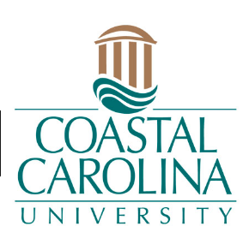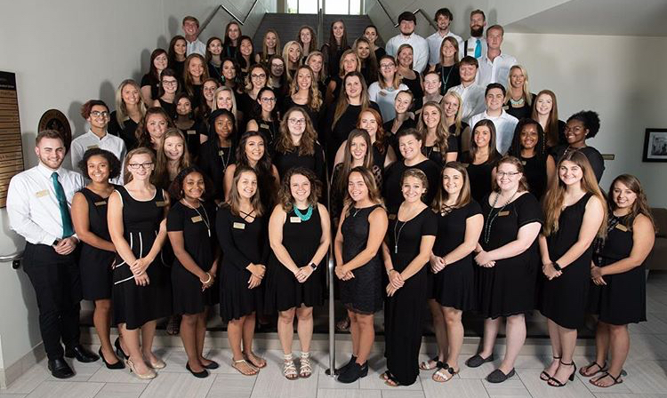

**CONTACT INFORMATION**

**Betsey Costner**

Clinical Placements and Academic Adviser

[btcostne@coastal.edu](mailto:btcostne@coastal.edu)

843.349.6958

**Amanda Darden**

Director of Teaching Fellows

[adarden1@coastal.edu](mailto:adarden1@coastal.edu)

843.349.2699

**SOCIAL MEDIA**

Instagram: @ccuteachingfellows

Facebook: @ccuteachingfellows

Website: www.coastal.edu//teachingfellowsprogram

**OVERVIEW**

**The Coastal Carolina University Teaching Fellows Program** is designed to offer students a unique, coordinated and collaborative opportunity to become teacher-leaders. Fellows participate in a number of professional development opportunities, including seminars, workshops, conferences, action research, service learning and leadership training. Their work is supported by a program director who oversees the Teaching Fellows program at CCU. Administered by the Center for Educator Recruitment, Retention and Advancement (CERRA), the program provides $24,000 scholarships/loans over four years for up to 200 outstanding high school seniors. Coastal Carolina University is one of 11 institutions in the state identified as a Teaching Fellow Institution.

**OPPERTUNITIES**

**TEACH Community**

The TEACH (Teacher Education and Creative Humanities) Community is for those students who plan to make teaching their life’s work. The TEACH Community give students many different opportunities, such as bonding with other education majors.

**Homewood Literacy Lessons**

Teaching Fellows received a grant that allows them to buy books for the surrounding community. The Teaching Fellows students work with professional teachers to make fun and interactive lessons that allows any education major to go into real classrooms and teach a full literacy lesson by themselves at Homewood Elementary.

**Field Experience**

Teaching Fellows begin classroom experiences their freshmen year and continue with different placements their sophomore year. In comparison to other education majors, they spend more time in the classroom before the start of their junior year.

**Parents’ Night Out**

This event is where professional staff members can drop off their children for a couple hours to have a night out by themselves, and the Teaching Fellows or education majors host fun interactive night to entertain the children.

**Coastal Carolina University**

**Teaching Fellows**