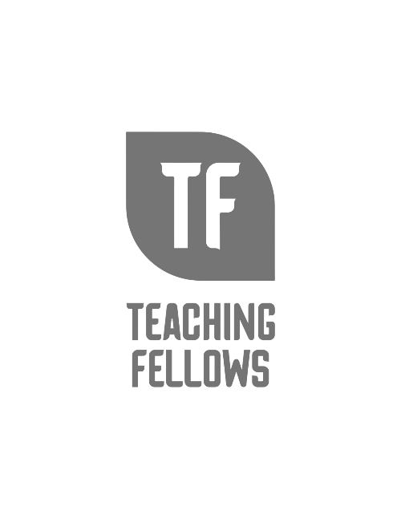Integrating Professional Function with Personal Purpose
Teaching Fellows Junior Conference
Mr. Vikas Srivastava

Session Descriptor: Too often the function of a teacher seems to overlook the purpose of a teacher. Function alone, without purpose, can lead to burn out. This workshop explores the intersection of professional function and personal purpose through mindful, restorative and trauma sensitive collective reflection and sharing. This workshop is appropriate for all educators of all grade levels and content areas. Participants will develop and define their own integrative model specific to their own felt purpose and function. Participants are encouraged to bring something to capture their reflections that will keep as a reminder (notebook, digital device, etc.).

Presenter Bio: Vikas Srivastava currently serves as HR Employee Relations at Legacy Early College [LEC] in Greenville, South Carolina. Vikas was initially recruited as Director of Mindfulness in 2018 to lead a 4k-12 whole school integration that included Mindfulness, Restorative Practices and Trauma Sensitivity through classroom workshops, scholar interventions for students at risk of expulsion, staff training and parent seminars. Vikas was invited to join the HR team in 2020 to further integrate these practices on an administrative level. This included the previous work, as well as HR related conflict mediation, protocols and recruitment. As a result, Vikas has developed a framework that has a very wide application with people and communities of all ages, backgrounds and belief systems. Vikas Srivastava graduated UC San Diego with a BA in Sociology and an emphasis on ethnic identities and urban studies. He earned his MA in Education from Harvard Graduate School of Education with an emphasis on school design. Over the last 20 years, he has worked as a counselor, teacher and administrator in grades preschool through college. His work includes public district, public charter and private schools serving both significantly under-resourced and affluent communities. Vikas has served as a board of directors for Kids for Peace, Sean O’Shea Foundation and the Tariq Khamisa Foundation. Personally, Vikas is an avid meditator, gardener, musician, chef and father.

