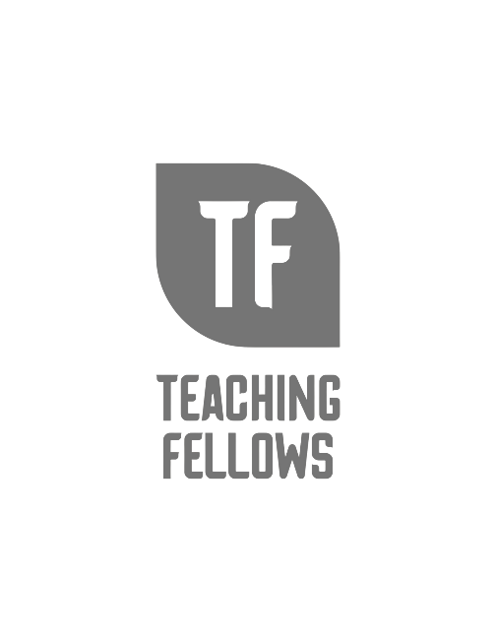
Teaching Fellows Junior Conference
Relationships Matter and Not Just With Students
Dr. Lindsay Simmons and Dr. Kimberly McCuiston

Session Descriptor: This session focuses on how a pre-service teacher can build rapport with their cooperating teacher and future mentor teacher. Strategies for collaboration, connection, and cohesion in effective relationships will be discussed. In this interactive workshop, attendees will have the opportunity to discuss the relationship from both perspectives and gain insight into the complex workings of collegiality.

Presenter Bio: Dr. Lindsay Simmons is an Associate Professor of Education and the Co-Director for the Center of Excellence for Teacher Retention and Induction in the Pee Dee at Francis Marion University. She also is a trainer for CERRA’s SC Mentor Training program and also teaches classroom management to student teachers.

Dr. Kimberly McCuiston is an Associate Professor of Education and the Director for the Center of Excellence for Teacher Retention and Induction in the Pee Dee at Francis Marion University. She also is the Director of Student Teaching and a trainer for CERRA's SC Mentor Training program.

