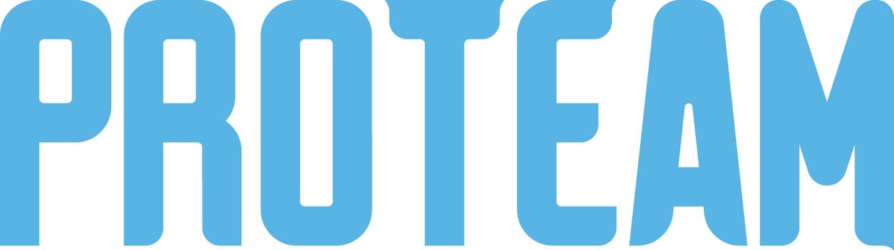
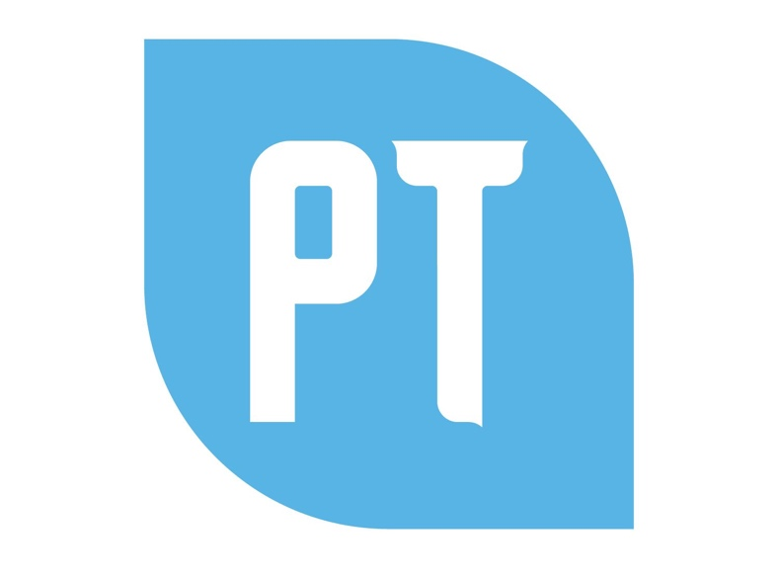

ProTeam Program Participation
DreamQuest, Eighth Edition

Certificate of Completion
Presented to

April 29, 2020

________________________________ ________________________________________
Principal ProTeam Instructor

