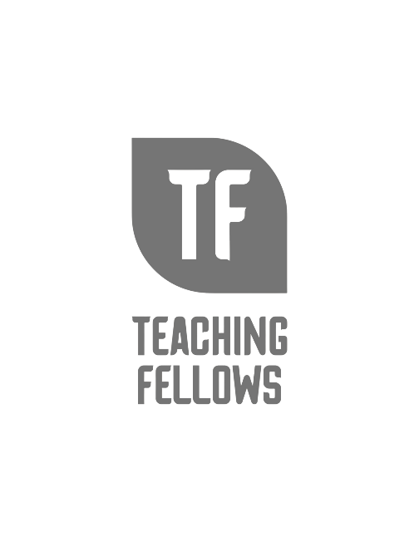
Teaching Fellows Junior Conference
Creating a Learning Environment Based on Access and Equity
Mr. Craig King
Session Descriptor: In this workshop, educators will analyze the mindsets in Dr. Camille Farrington’s research, Academic Mindsets as a Critical Component of Deeper Learning, and correlate those student mindsets to being important factors for creating a learning environment based on access and equity.

Presenter Bio: Mr. Craig Q. King serves as Director of Teacher Leadership for the Palmetto State Teachers Association, Site Coordinator for the Call Me MiSTER Program at Columbia College, and the CEO/Founder the Craig King Group, LLC. He is a 2004 and 2007 graduate of South Carolina State University where he received his B.S. in Elementary Education and his Master’s degree in Rehabilitation Counseling. He is a former third grade teacher and taught at Whittaker Elementary School in Orangeburg, South Carolina for seven years. Mr. King is a National Board Certified Teacher holding his certification as an Early Childhood Generalist. Mr. King is the author of the book The Path to Exceptional Living: 15 Lessons to Living an Extraordinary Life. He is the co-host of the Conversations with Craig & Kobie Podcast and host of The PSTA Podcast. He is married to Tasia King and they have one daughter, Saniah. He is a proud 23-year cancer survivor and understands his purpose in life is to capture, inspire, teach, and serve the people of the world!

