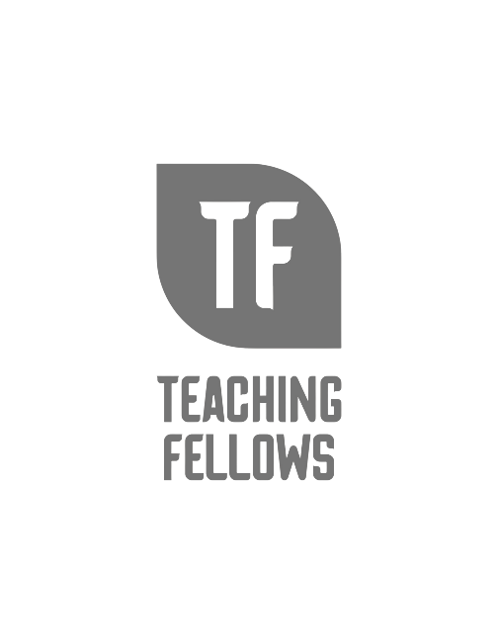
Teaching Fellows Junior Conference
Telling YOUR Story: Resume and Interview Skills Workshop
Mr. Derrick Hines
Session Descriptor: An exercise in personal advocacy, this workshop aims to empower young professionals in their search for a full-time teaching position. Through interactive discussion and situational analysis, participants will become more aware of strategies to promote their skills and abilities to potential employers.
Presenter Bio: Originally from Spartanburg, South Carolina, Derrick Hines is the Director of the Teaching Fellows Program and the Teacher Cadet College Coordinator for the University of South Carolina's College of Education. Mr. Hines previously spent six years teaching United States History and Physical Education at Dreher High School in Richland County School District One. Prior to his time at Dreher High School, Mr. Hines taught at E.L. Wright Middle School in Richland County School District Two where he taught Physical Education and was tasked with creating and piloting the elective curriculum for the new course of Media Literacy. Mr. Hines has served as a University of South Carolina College of Education Coaching Teacher for six years, hosting several pre-service practicum and internship A & B student-teachers. He also assisted in the creation of the Richland County School District One United States History and the Constitution pacing guide prior to the 2012-2013 school year. Mr. Hines also served in various athletic coaching roles during his time in public education, with 8 years of experience in football, tennis, and strength and conditioning. Mr. Hines is a graduate of the University of South Carolina's graduate school with an Interdisciplinary Master of Arts in Physical Education. He completed his Bachelor of Science degree in Physical Education at Newberry College, where he also minored in History and German as a member of the South Carolina Teaching Fellows Program.

