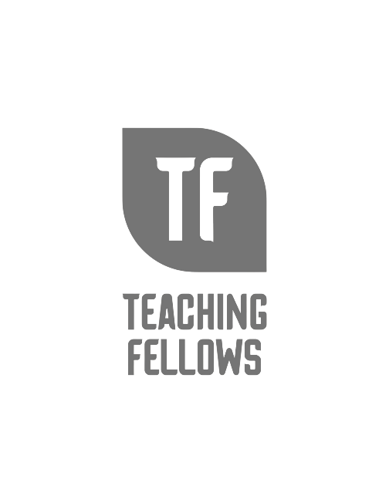
Teaching Fellows Junior Conference
Developing Powerful Messages
Dr. Jenna Hallman

Session Descriptor: Teacher leaders advocate professionally for themselves, their students, their schools and districts, and the profession as a whole. Advocacy begins with the development of powerful messages (stories). During our time together, I will share advice about advocating with policymakers and YOU will begin to develop your own powerful message.

Presenter Bio: Jenna was born and raised in Coventry, Connecticut. She has a BA in Early Childhood Education from USC-Upstate and an M.Ed. in Educational Leadership and Supervision from Clemson University. She also holds a Ph.D. in Education with a specialization in Curriculum, Instruction, and Assessment from Walden University. Her dissertation is titled "Impact of the Southern State Teaching Program on the Preparation of Teacher Leaders." Jenna started teaching in 1999, achieved National Board Certification as an Early Childhood Generalist in 2002, successfully renewed this certification in 2012, and maintained the certificate in 2022. Most of her classroom career was spent teaching second grade at Calhoun Academy of the Arts in Anderson School District Five. She finished her time at Calhoun as the school science specialist. While in Anderson District Five, Jenna worked on curriculum writing teams, provided professional development focused on science and math instruction, directed the Camp Invention program for the district, mentored early career educators, and hosted interns from local universities. Jenna initially came to CERRA to serve a year-long residency as the 2008-2009 SC Teacher of the Year. Following this residency, she assumed the role of Program Director for Teaching Fellows and National Board support and later added CERRA's Mentoring and Induction and Teacher Leadership programs to her list of responsibilities. Along with her Program Director duties, Jenna served as the Assistant Executive Director from 2012 until she was named Interim Executive Director in March 2021. She began serving as Executive Director on July 1, 2021.

