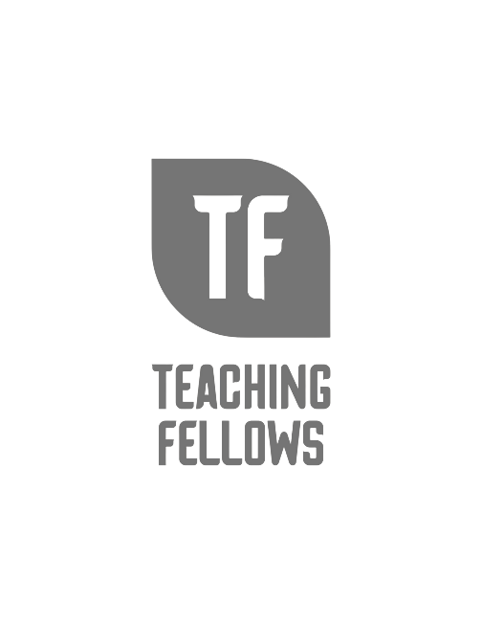
Teaching Fellows Junior Conference
GIRL BOSS READERS: 3 Strategies to Get Girls to Love Reading Too
Ms. Kelli Floyd
Session Descriptor: GIRL BOSS READERS. Of course all girls are expected to love reading, but do they really? Success in the classroom comes from consistent attention to the impossible, and getting girls to believe in themselves starts with them being comfortable in their own skin. As Coco Chanel said, "A girl should be two things – Who and What she Wants.” This interactive presentation is here to RISE and SLAY 3 strategies to build a reading community that girls will find safe, connected and fun. So of course wear your prettiest pink – WE DO!.
Presenter Bio: Teaching English for 30 years, Ms. K. Floyd has taught grades 7-12, affording her beautiful opportunities of teaching children in both rural and inner-city schools. She is currently teaching sophomore English at Lake View High School in rural Lake View, SC and is serving as the Teacher Induction Instructor for Dillion District Four. She has served as a mentor to both first-year teachers as well as student teachers and provides professional development at national, state, and local levels on topics ranging from gender-based learning, best practices, technology integration, and reading and literacy across the curriculum. She currently lives in Myrtle Beach and when she can't be found sitting on the sand, she can be found frequenting local antique and consignment shops.

