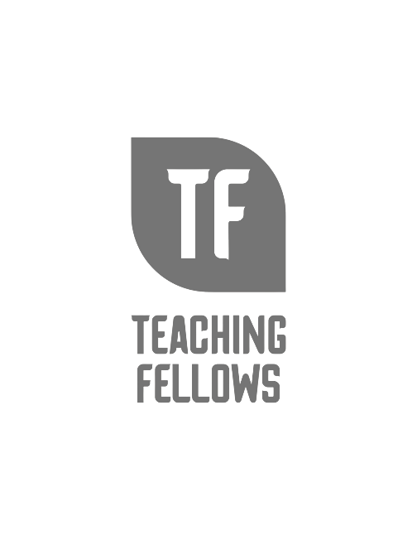
Teaching Fellows Junior Conference
Serving Students with Disabilities in the General Education Classroom
Dr. Angie Slatton

Session Descriptor: Based on data collected by the National Center for Educational Statistics, the average enrollment of students with disabilities in public schools is 15%. Public school educators are presented with the challenge of educating all students, including those with disabilities. In this presentation, I will provide key points of supporting students with disabilities in the general education classroom. This will include an introduction to the Universal Design for Learning, High Leverage practices for inclusive classrooms, and the use of assistive technology to support various learning styles. We will also discuss the responsibility of providing and documenting classroom accommodations. Easily accessible resources will be provided along with recommendations of who can support implementing these strategies at the district level.

Presenter Bio: Dr. Angie Slatton has served as the Director of Special Services in District Five of Lexington and Richland Counties in Columbia, SC since July, 2014. Prior to her service in District 5, she spent time as a federal grant director at the South Carolina Department of Education, a special education coordinator, and a classroom teacher. She earned her BA and MAT from Winthrop University, EdS from SC State University, and PhD from the University of South Carolina. A focus of her career has been building relationships between community partners and school districts to offer effective special education programs for students with disabilities. In her spare time, she enjoys spending time traveling with her children and husband.

