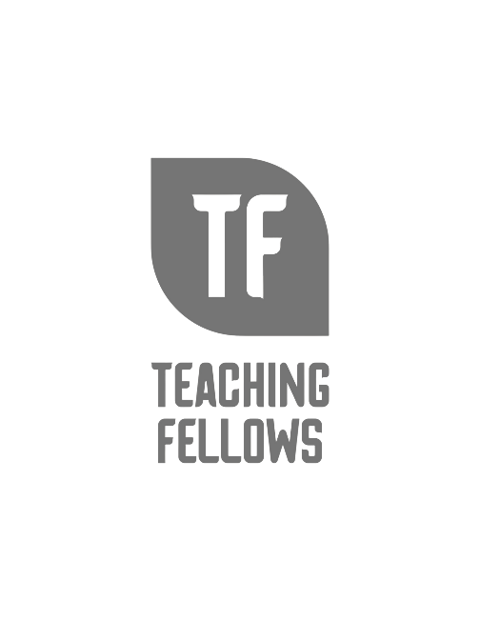
Teaching Fellows Junior Conference
Embracing the STEAM Studio
Dr. Ian O’Byrne

Session Descriptor: This session will focus on bringing project-based learning (PBL) into all classrooms through unique workshops and powerful hands-on learning experiences. We will help teachers engage young people in work that responds to authentic problems and real-world questions, and believe that making, building and design are pathways to an empathetic, socially just education. We share curricula for STEAM-oriented projects and design challenges, intellectual sparks for all grade levels, and an extensive collection of readings and videos about creativity as a practice. This workshop will help educators launch real, community-oriented classroom projects that are aligned with specific learning objectives, and ignite conversations about pedagogy in new contexts.

Presenter Bio: Dr. W. Ian O’Byrne (@wiobyrne) is an associate professor of literacy education at the College of Charleston in South Carolina. His research focuses on the dispositions and literacy practices of individuals as they read, write, and communicate in online and/or hybrid spaces. Ian is the author of many journal articles and book chapters focusing on initiatives ranging from online and hybrid coursework, integrating technology in the classroom, computational thinking, and supporting marginalized students in literacy practices. His work can be found on his website (https://wiobyrne.com/) or in his weekly newsletter (https://digitallyliterate.net/).

