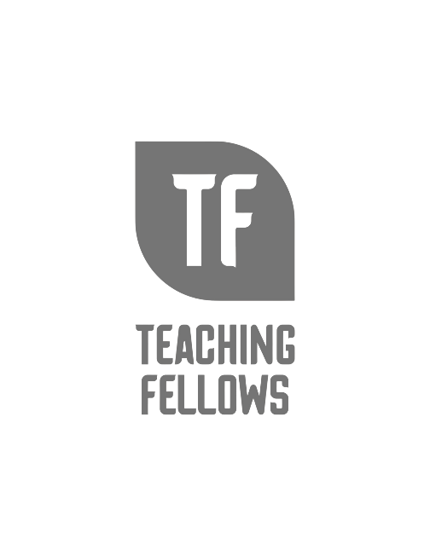
Teaching Fellows Junior Conference
Diversity, Equity, and Inclusion in Action: Maximum Impact
Mrs. Christy James, Mrs. Katherine Freligh, and Ms. Alana Lewis
Session Descriptor: DEI (Diversity, Equity, and Inclusion) is more than just another education buzzword. In this session, we will focus on identifying actions you can take to maximize the impact of creating and using resources and programs that truly serve all students and your community. Participants will have opportunities to examine their current instructional practices, explore the potential for community partnerships, and discuss ways to infuse DEI throughout their interactions with students and families. Related book titles and programming ideas will be shared.

Presenter Bio: Christy James, MLIS, is the district library and media services coordinator for Charleston County School District. Prior to that she was a middle school librarian and classroom teacher for 20 years. Christy was selected as a member of ALA’s Policy Cohort 4 in 2022. She was recognized as a 2020 Library Journal Mover and Shaker Innovator and the 2018 F.
William Summers Outstanding Alumni Award from the School of Library and Information Science at the University of South Carolina. Christy is passionate about equity and access and advocating for and promoting the value of school librarians.

Katherine Freligh, MLIS, is on the board of the South Carolina Association of School Librarians, currently serving as the Legislative Chair. She is the Immediate Past President of the Charleston County Association of School Librarians and serves on the district-wide Teacher Librarian Advisory Team. She is the 2023 Lowcountry Regional Librarian of the Year and is a Teacher Librarian at Mary Ford Early Learning & Family Center in Charleston County. She has spent a decade in education, first as a middle school science teacher, then in library with students pre-K through 5th grade and now spends any free time in the woods, or reading. Or reading in the woods.

Alana Lewis, MLIS, is the school librarian at Sangaree Middle School in Berkeley County School District. She is the Diversity Equity Inclusion Chair for the South Carolina Association of School Librarians and was recognized as the Lowcountry Regional School Librarian of the Year for 2023-2024. Prior to school librarianship, Alana was an academic librarian at College of Charleston.

