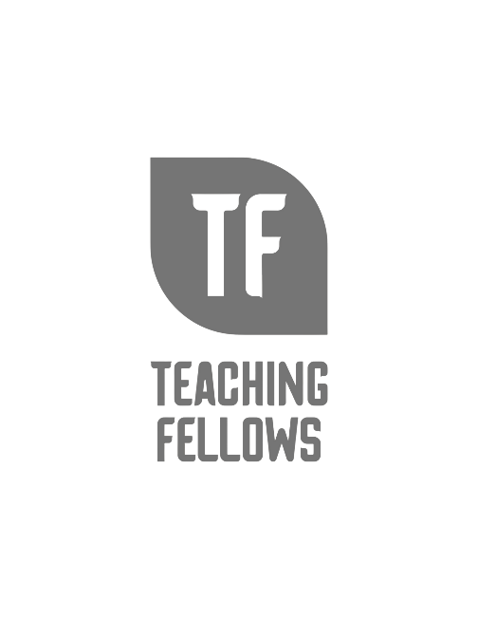
Teaching Fellows Junior Conference
Ease into Education with Care and Synergy
Dr. LaWanda Felder and Dr. Miranda Page
Session Descriptor: Join us for an engaging and insightful session that explores the transformative power of cultivating synergy and care in educational environments. This session aims to inspire educators to foster a holistic approach to learning that prioritizes collaboration, emotional well-being, and the development of strong interpersonal connections within the educational community. In an era where academic pressures and societal expectations can be overwhelming, it is crucial to shift our focus towards creating nurturing educational environments. This session will give practical strategies that emphasize the importance of synergy and care in promoting not only academic success but also personal growth and fulfillment.
Presenter Bio: Dr. LaWanda R. Felder is a School Counselor in Berkeley County School for over 25 years. She is an Adjunct Professor at South Carolina State University and The Citadel. She has served her state association for over the last 10 years and currently serves as Executive Director of PSSCA. Dr. Miranda M. Page has been a Dillon School District School Counselor for over 25 years. She previously served as PSSCA in many capacities.

