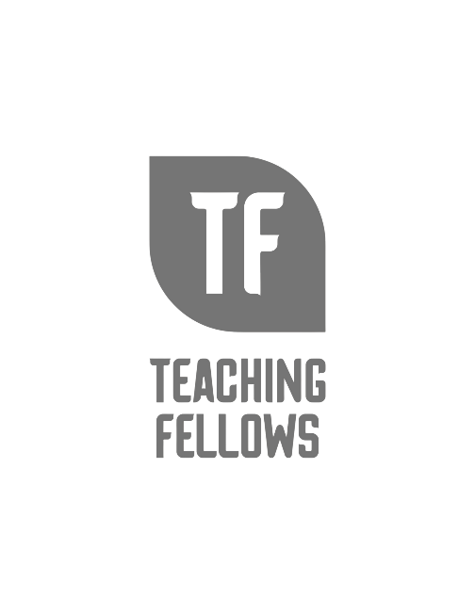
Teaching Fellows Junior Conference
The Christian Teacher in the Public Classroom
Dr. Bob Cline
Session Descriptor: This presentation includes ideas on how a Christian teacher can successfully navigate the civil laws and local school/district policies regarding religious expression in a public-school classroom. The presenter will emphasize showing respect to all students regardless of their religious background or affiliation, and how love always wins in helping students learn and to be comfortable with your Christian convictions. The workshop includes an overview of primary legislation and court cases that have shaped the current classroom environment regarding religious expression. Participants will explore some practical and legal do's and don'ts... what teachers and students can and cannot do regarding religious expression. The workshop concludes with some positive and practical opportunities about how their Christian faith can help students learn and relate well with others… including some QR codes they can access to learn more.
Presenter Bio: Dr. Bob Cline is a retired Pastor and former Vice President of Anderson University. He and his wife, Angela live in Myrtle Beach, SC. Dr. Cline is currently mentoring younger pastors, students, and church planters in the Carolinas seeking to be a source of encouragement.

