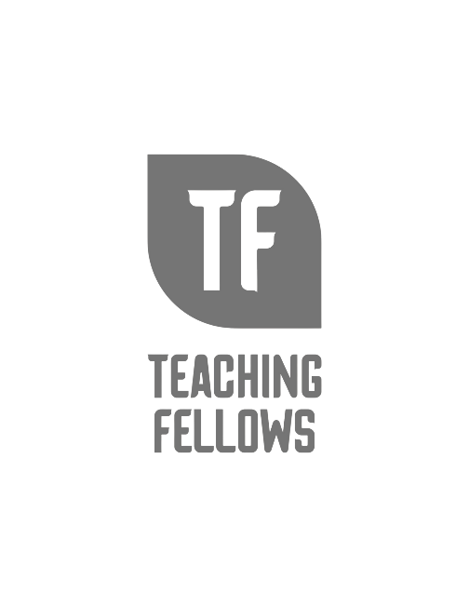
Teaching Fellows Junior Conference
Building Futures and Changing Lives: Join the Movement and Discover the Power of Teaching Children of Poverty Scholars
Mrs. Jane Brandis and Fellows
Session Descriptor: This presentation invites Teaching Fellows to join this transformative movement with the Teaching Children of Poverty Scholars organization, a dynamic community better preparing teachers to address the unique needs of under-resourced children and their families. Learn about distinctive program offerings and hear firsthand from current and former Scholars who will share their experiences, illustrating the real-world impact of this influential organization on the lives of those who need it most. Discover how you, as a Teaching Fellow, can become a catalyst for change, building futures and changing lives through the Teaching Children of Poverty Scholars program.
Presenter Bio: Mrs. Brandis has been in education for over 35 years. She has served as a classroom teacher, School-level Curriculum Coordinator, Teacher Specialist for the SC State Department of Education, the Coordinator of Clinical Experiences/Assistant Professor in the School of Education at Francis Marion University and is currently a retired Professor Emeritus working as a Project Coordinator for the Center of Excellence to Prepare Teachers of Children of Poverty and as a Support Coach for new teachers with the Center of Excellence for Teacher Retention in the Pee Dee.
Mrs. Brandis is joined in her presentation by the following teachers and former Fellows:
Ms. Brianna Bradley: South Florence High School/Florence, SC, Algebra 1 and Geometry/9th grade
Ms. Tanika Gause: Lamar High School/Lamar, SC, Biology/ Earth Science/9th and 10th grade
Ms. Brooklyn Goodall: Freshman/Secondary Math Education Major
Mr. Ahmad Leggette: Senior/Early Childhood Major/Francis Marion University,
Ms. Jimmy Patel: Delmae Heights Elementary School/Florence, SC, 2nd grade

