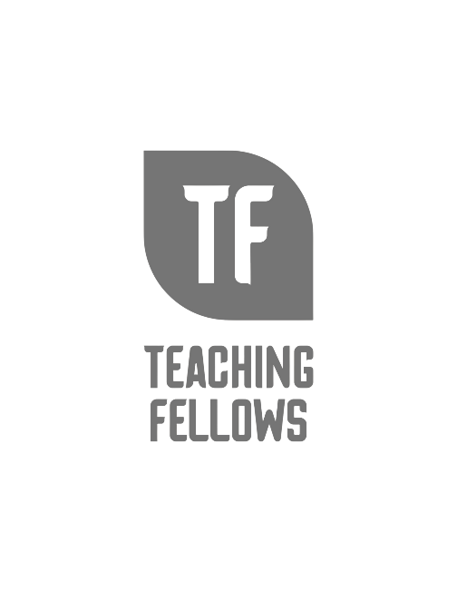
Teaching Fellows Junior Conference
Reinforcing Multilingual Learners’ Content Area Learning
Dr. Jennifer Altieri
Session Descriptor: Learn about content area strategies which can help multilingual learners expand their academic vocabulary and deepen content area understanding. Participants will learn how to use the strategies and be able to examine student examples. Many activities involve drawing/visualizing.
Presenter Bio: Dr. Altieri has a strong interest in disciplinary literacy. She has written several textbooks published by the International Literacy Association and a textbook published by Heinemann.

