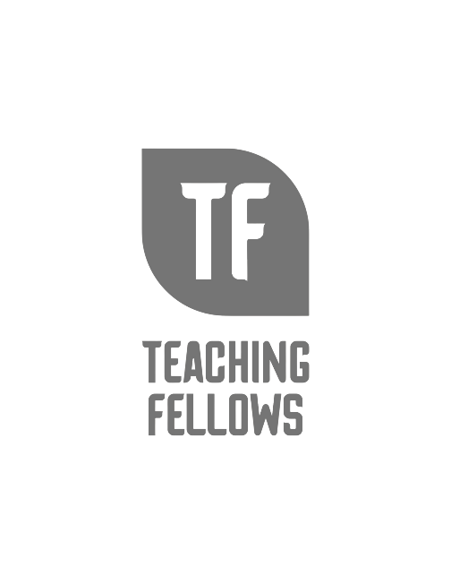
Teaching Fellows Junior Conference
I am in my “Whew, Chile! Making it to Year 5!”
Amaris Reeder

Session Descriptor: As a new teacher, there are circumstances you face that college doesn’t prepare you for. It’s not written in the EDU 101 rubric to not take work home on the weekends. New educators face challenges that need nurturing. How do you survive and protect yourself from being another statistic as an educator leaving the field after 5 years? Franklin Covey provided 7 ways to do this by managing yourself. I plan to engage participants in conversation and physical activities to help them see what these 7 components look like within surviving the first 5 years of teaching.

Presenter Bio: I am in my 9th year teaching middle school special education. I'm an alumnus of Lander University where I received my Bachelor in special ed. I received my Masters of Education at Anderson University and my Ed.S degree in Literacy from Converse University. I have a book out called "Whew Chile Making it to Year 5: A guide to Surviving your first 5 years of teaching." I'm super passionate about mental health, art, and inclusion!

