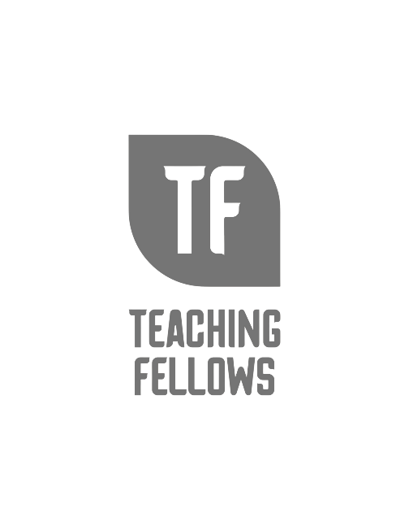
Teaching Fellows Junior Conference
From Teaching Fellows to Teacher Leaders, Building Leadership Capacity from Day One
Mrs. Reneé Atkinson

Session Descriptor: During this session we will explore the Teacher leadership Competencies and begin to plan for the transition from Teaching Fellows to Teacher Leaders.

Presenter Bio: Reneé is an English teacher at Aynor High. This is her 21st year in education and her 17th teaching in the Horry County School District. However, she never considered teaching until after earning her bachelor’s in history with a minor in English at Clemson University. She went on to earn her master’s in secondary English from Francis Marion University and an education specialist degree in curriculum and instruction from Liberty University. She is also a National Board Certified teacher. While she has spent time in various roles over the past two decades, Renee’ says she’s happiest in the classroom because that’s where she can make the biggest difference for children.
As the State Teacher of the Year, Renee provides mentoring, attend speaking engagements, work with Teacher Cadets and Teaching Fellows, lead the State Teacher Forum, and serve as the state spokesperson for over 55,000 educators. She will also move forward to compete for the title of National Teacher of the Year.
​Renee is serving a one year residency with the Center for Educator Recruitment, Retention, and Advancement (CERRA). She will be a roving ambassador providing mentoring, attending speaking engagements, working with Teacher Cadets and Teaching Fellows, leading the State Teacher Forum, and serving as the state spokesperson for over 55,000 educators.

