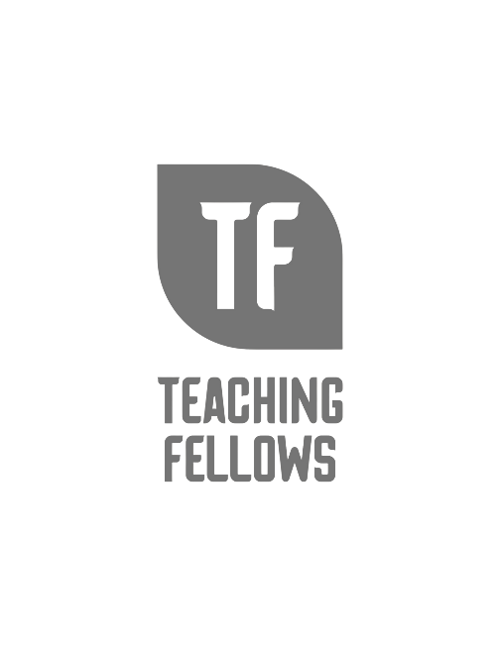
Teaching Fellows Junior Conference
Science, Social Studies, Math and More: Using Student Created Formula Poetry Throughout the Day
Dr. Jennifer Altieri
Session Descriptor: Learn how to incorporate student-created formula poetry throughout the various content areas. See student examples from various grade levels and learn how formula poetry can enhance literacy development and content knowledge.
Presenter Bio: Dr. Altieri has a strong interest in disciplinary literacy. She has written several textbooks published by the International Literacy Association and a textbook published by Heinemann.

